CC School Hoodie Order Form

Carberry Collegiate Student Council will be giving the student body the opportunity to purchase school hoodies before Christmas. Students will have a chance to try on the hoodies to determine size and fabric they would like before purchasing. There will be a table set up outside of the student council room from 12 to 1 on:
- November 14th ,15th , 21st, 22nd
- November 16th & at gr. 9-12 SLCs 4:30-6:30pm
- November 17th & at gr. 9-12 SLCs 4:30-6:30pm

- Order forms will be DUE on November 22nd by 3:30pm so we can receive them back before we spilt for Christmas break.
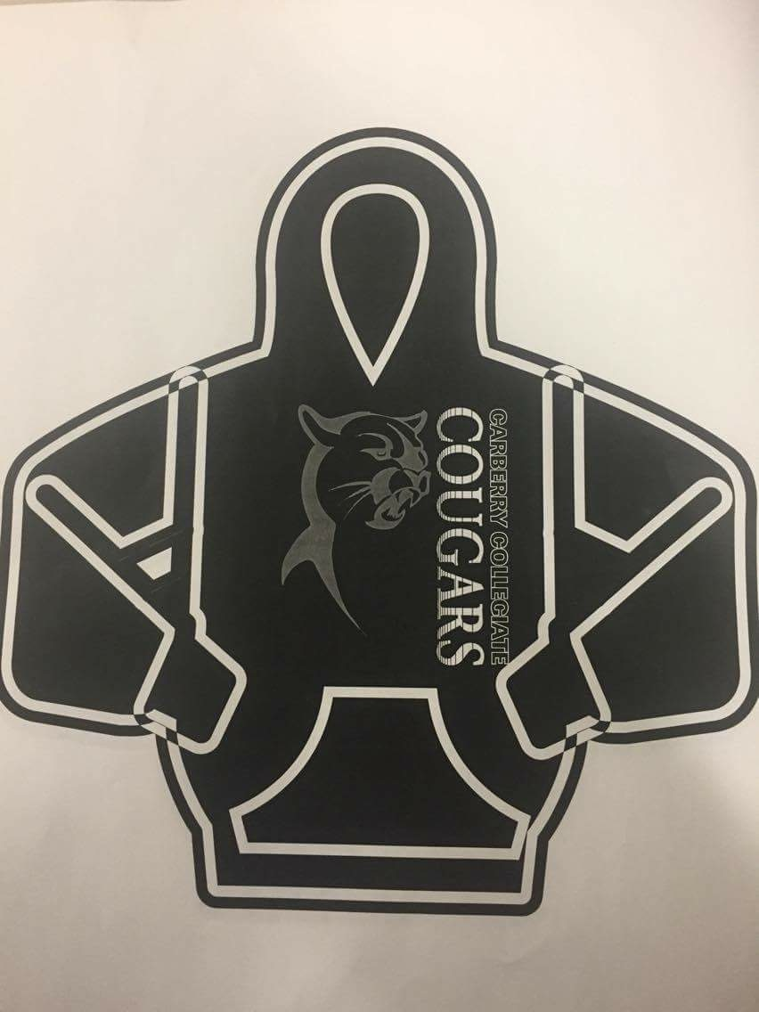
- Make checks payable to CC Senior High Student Council.
Cheques will NOT be deposited before Dec. 2nd.
- Hand in orders to the student council table during fitting hours.

There will be two different hoodies to select from:
- Glidan Fleece Hooded Sweatshirt – 100% polyester fleece
- $58 Dollars (front logo & tax included)
- Unisex Adult Sizes XS-4XL
- Youth Sizes S-XL
- Brand: Authentic T-Shirt Company
- http://www.sanmarcanada.com/cs/CatalogBrowser?id=35068&prodimage=imglib/catl/F2011_Form_Angle_BlackGold_042015.jpg&swatch=Black%2FGold&parentId=125&catid=111

- Cedar Point Pullover Hoodie – 80% Cotton & 20% Polyester
- $58 Dollars (front logo & tax included)
- Mens S – 4XL
- Ladies XS – 2XL (a little more fitted)
- Youth S – XL
- http://www.canadasportswear.com/Product.aspx?MainID=49&SubCatID=111&ProductSku=L00660
- www.canadasportswear.com (search SKU# L00660 for Mens, L00661 Ladies, L0660Y for Youth)

The front logo is in two shades of gray. The cougar is like a shadow and the words Carberry Collegiate will stand out more. Writing on the sleeves will be in gray as well.
If you would like to secretly order a hoodie for someone for Christmas you may place your order directly with Mrs. R. Dyck by emailing her at rdyck@bpsd.mb.ca. Only orders that are completely, correctly, and fully filled out will be accepted this way. Ordering in person is preferred.
We are offering the option to customize your hoodies this year as well. Please keep hobbies and nicknames school appropriate if this is something you would like on your hoodie. It will be $4 per line.
Step 1: Student Information
Student Name: ____________________________________________________________________________
Grade & Homeroom (gr. 5-8s): ________________________________________________________________
Step 2: Select Hoodie Type
Glidan Fleece Hooded Sweatshirt (100% polyester) | Cedar Point Pullover Hoodie (cotton polyester blend)
Size: _____________________________  - Unisex Adult Sizes XS-4XL  - Youth Sizes S-XL  Colour: circle one  Black/Yellow OR Black/Charcoal | Size: _____________________________  - Mens S – 4XL  - Ladies XS – 2XL (a little more fitted)  - Youth S – XL  Colour: circle one  Black OR Mid grey

Step 3: Customization (optional) _____ Yes _______ No thanks
Right Arm (name & number) | Left Arm (activity list or sports)

Step 4: Price & Pay
Hoodie base price: $58.00
# of lines of customization: _______ x $4 = + $___________
Total Cost: $___________
Payment Method (circle one): CASH or Cheque
Order taken by: _____________________________________ (Student Council use only)

